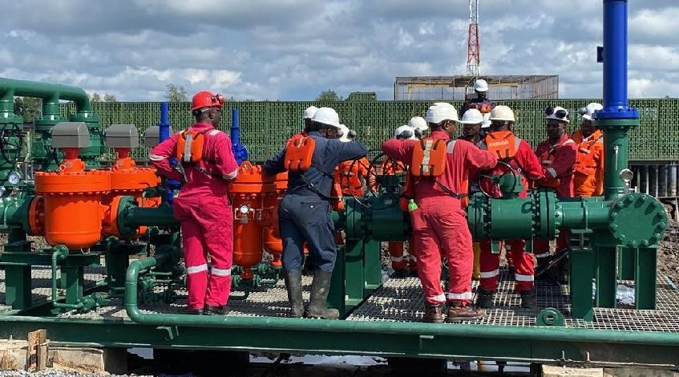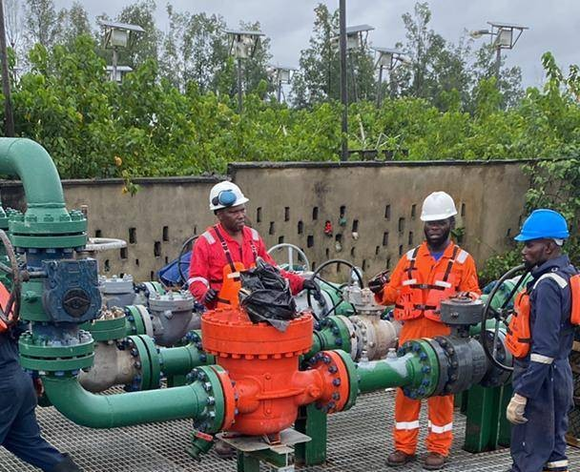

MARINE I CARGO SURVEY | STEVEDORING I ENGINEERING

WHO WE ARE

Vicbriggs Nigeria Limited is a technically equipped company aimed at satisfying the requirement for the upstream and downstream sectors of the Oil and Gas Industries. We are duly registered with our key staff drawn from well experienced personnel's in the business. We are indigenous and from the Niger Delta Region and seek to provide competitive technical and quality support services to our clients in the industry with specialty in Civil / Mechanical Construction, Pipeline Repairs and maintenance, Surveillance Services, Manpower Supply, IT/Consultancy Services and Marine Services (Creek and Sea-going Vessels).

For nearly a two decade, Vicbriggs Nigeria Limited has provided a broad scope of services in the Oil & Gas business, as well as civil construction services to large spectrum of clients in private and public sector. Vicbrigg reputation for integrity, innovation and performance has positioned the company as a well-respected leader in the industry. As we have expanded our capabilities over the years, one fact has remained constant — our clients are our greatest asset.

This mind-set and the unrelenting commitment to meet those industry objectives of health, safety, environment, community issues, competence and capacity have been what Vicbriggs Nigeria Limited has been known for. As we go further to deliver service to our clients, we are prepared to drive our roles and responsibilities with

that history of excellence.

Whether you are an engineer, an owner, or a potential partner, we welcome the opportunity to discuss Vicbriggs Nigeria Limited capabilities with you.

*Vicbriggs’s Core Philosophy*

Our philosophy aims at providing the best solution at a cost effective price while meeting with clients’ standards and specifications in Quality, Safety and most Environmentally friendly way at due dates. From our mission and vision to our footprints in delivering services, we have in the last one decade demonstrated a commitment to the best the industry can have.

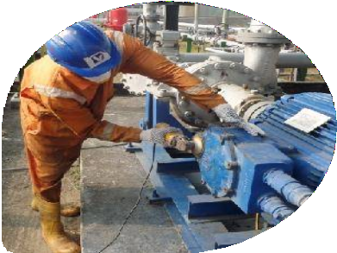

Operational Goals

* Minimum Downtime

- Maximize Operational Efficiency

* Focus on Health Safely and fhe Environment

VicBriggs Nigeria Limited operates with the best quality management systems which, where required by legislation or risk, comply with the requirements of

ISO 9001: 2015,

accredited and certified QFS Management Systems LLP.

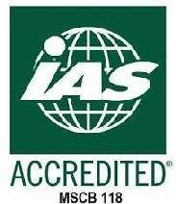

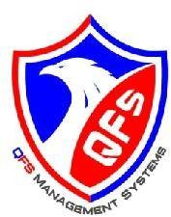

Vision & Mission

*Our vision is to ensure clients’ needs are met on target at moderate economy, quality, safety and minimum environmental impact.*

*And Our mission is to provide* adequafe *Technical and Support Services to ensure our client’s* Success *in Business*





MARINE | CARGO SURVEY | STEVEDORING | ENGINEERING

**VICBRIGGS CORPORATE POLICIES**

We have a policy of carrying out its business in strict compliance with the laid down policies of the client in respect to Health, safety and environment matters in such a manner that our employees and others are adequately protected from any exposure to danger. We strive always to consciously minimize, to large extent damage to property, human beings and environment. The environment is of paramount importance to us.

Consequently, we ensure minimum damage to the environment when working and also ensure that the environment is left almost as it were before the start of project.

### QUALITY POLICIES

Here at VICBRIGGS NIGERIA LIMITED to provide services that complied with international acceptable standard of quality and client prescribed quality requirements. Therefore, it is our Policy to:

* Provide services that constantly meet the present and future needs of our customers, thereby gaining enthusiastic customers trust and support.
* Pursue continuous improvement in quality activity, so that each employee does his or her job right the first time. Eliminate barriers to creativity, so we can focus our collective genius on our customer's requirement and provide unique products and services that are best in their classes in both function and reliability.
* Create an environment for total quality management by developing an empowering vision that is communicated to our customers, so we can provide services that are fully meet the requirement of our customers.
* We pledge to continue this commitment to our customers with investment in research, development and training that are well beyond industry norms.
* Likewise our continued commitment to service will be demonstrated with a growing list of options for customers' education and support.

Health Policy

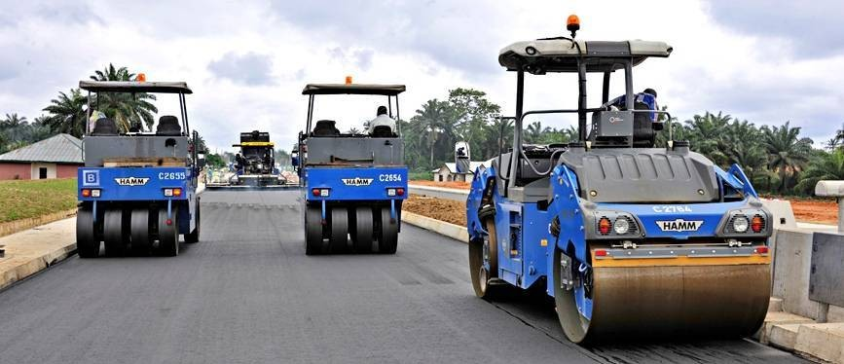

##### Total health promotion and protection

for all our workers

Security Policy Environmental Policy

##### Safety for all Staff, Clean and healthy Equipments and Clients environment for workers at all project sites and host community

MARINE I CARGO SURVEY | STEVEDORING | ENGINEERING

Community Affairs, Safety, Health, Environment and Security (CASHES)

* 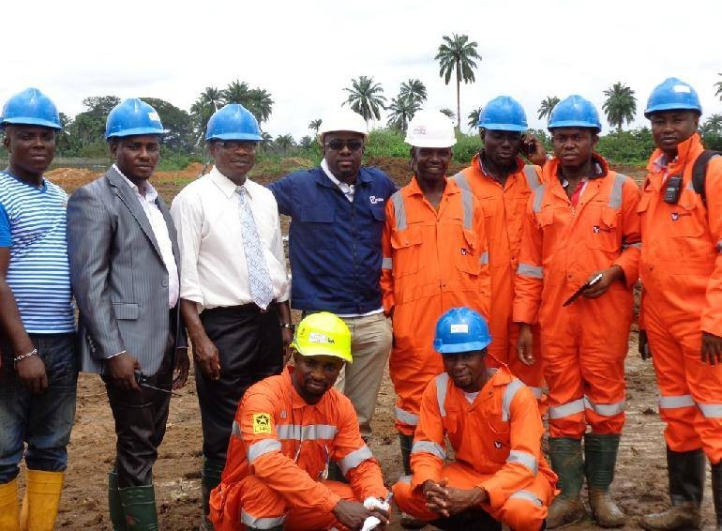That Management is fully committed to the administration and enforcement of CASHES standard in all our operations.
* That CASHES is as important as any other aspect of our mainstream business operation, it must be given priority attention.
* That everyone is responsible for their own safety and their colleagues' safety at work site.
* That unconditional acceptance by staff of compliance with company's CASHES policy is a pre-requisite for employment.
* That we shall observe all laid down safety regulations of our clients as well as complies with all regulations on safety at work and environment in all the statute books of the Federal Republic of Nigeria.
* That the safety and health of our workers, protection of the environment and security of workers and equipment must be accorded priority attention in our entire work site.
* The company will respect the culture and tradition of host community and involve itself in the affairs of the community as much as is practically possible. At least 60% of the work force on site will be from the host community.
* That enough resources will be set aside for CASHES management in

the company.

* Regular training of staff on various aspect of CASHES management will be accorded priority attention at all times.
* That we shall encourage and motivate our employees by recognizing good HSES performance through CASHES awards.
* That adequate disciplinary actions will be taken against employees for flagrant violation or regular breach of HSES rules.

To implement the above policy, work/activity will not commence until all CASHES issues are satisfied. Every employee should report to their supervisor if they believe that any act or condition is contrary to the company CASHES policy.

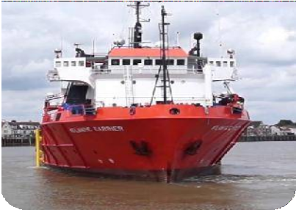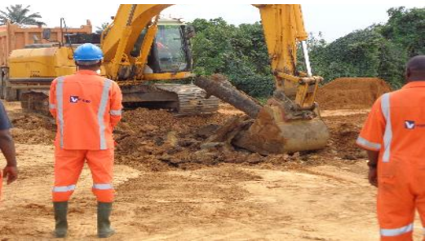

**VViiccbbrriiggggss**

**N I G E R I A L I M I T E D**

Our Services and Solutions

    

We at VICBRIGGS NIGERIA LIMITED, have

extensive experience providing engineering

RVI ES

and technology so that our clients can focus on their core business strengths. Integrated work practices

services and delivering solutions for oil and gas and energy facilities, both onshore and offshore. We support our clients in all the phases of an EPC project, from security to procurement and commissioning.

VICBRIGGS NIGERIA LIMITED, have the capability to manage the personnel, plant and machinery, facilities

also include:

* MARINE SUPPORT SERVICES
* ENGINEERING & SECURITY SURVEILLANCE
* DREDGING AND CONSTRUCTION

We provide marine support services to projects of any scale.



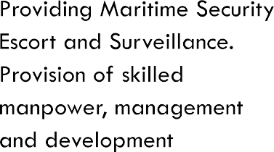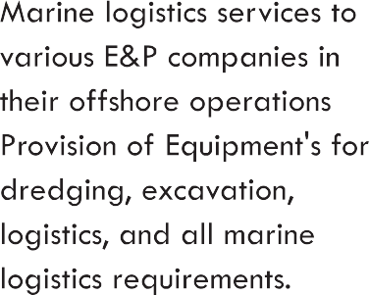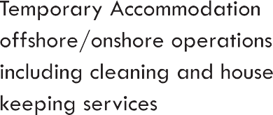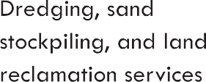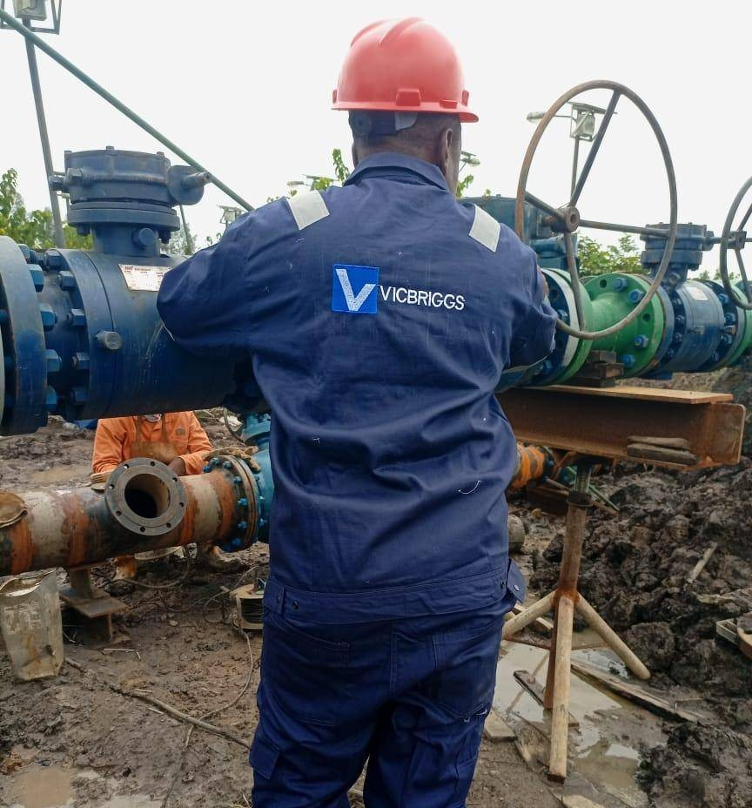

 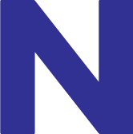  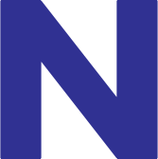 

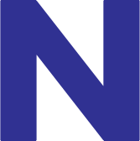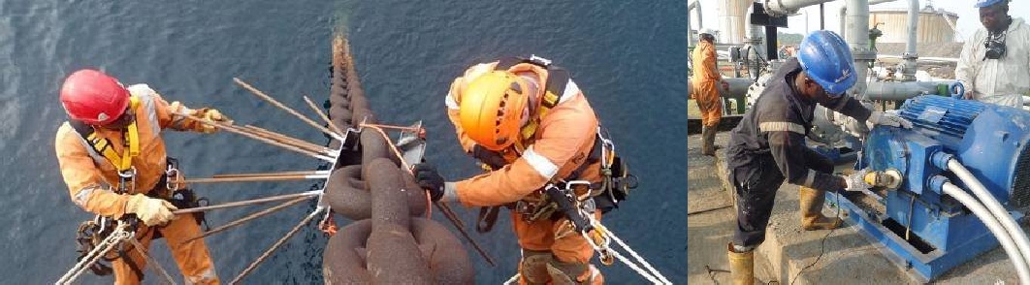

*is* capab/e of exectifing *m°i° r* construction services espec/a//y in the *areas* of the Management *and* Operation of Onshore/offshore *Production* Facilities *IPlatforms and* ffie proc/sion of Engineering, Mod/fication *and* Maintenance Services for these facilities *which* we *have carried out satisfactorily* over flue years. We *also carry out Production* Facilities inspection *and* Maintenance.

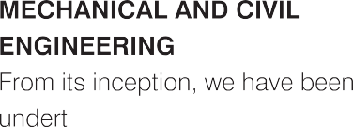aking various mechanical and civil engineering contracts. This includes projects like: the fabrication and installation/erection of steel/composite structures, office building, barge repairs, replacement and fabrication of cabins, fabrication of waste tank, large capacity storage tank, fabrication of over head tanks and minor road construction and repairs.

Maintenance overhaul of heavy- duty machines including construction, welding and fabrication covers the following:

* Mechanical/ Piping/ Structural/ I&E- Design, Fabrication and Installations of Inland, Shelf and

Deepwater Oil and Gas

Facilities and Structures.

* Facility Commissioning and Operation.
* Living Quarters Designs,

Fabrication and Installations.

* Facility Commissioning and Operation.
* Inland and Offshore Pipeline Installations.

CONSTRUCTION SERVICES &

CIVIL WORKS



VICBRIGGS NIGERIA LIMITED

has a mission to meet the increasing demand for responsive, cost-effective, quality, construction management services for complex projects.

Our construction and civil work Services include but are not limited to the following:

* Depot Construction
* Terminal Construction and Maintenance
* Building Construction
* Road Construction
* Project Management services

##### INSTALLATION AND UPGRADE OF ONSHORE/OFFSHORE PRODUCTION FACILITIES & PLATFORM ONSHORE/ OFFSHORE SCAFFOLDING



**VViiccbbrriiggggss**

**N I G E R I A L I M I T E D**

PIPELI SERVICES

FLOWLINE CONSTRUCTION PIPELINE MAINTENANCE SERVICES

We at VICBRIGGS NIGERIA LIMITED, have

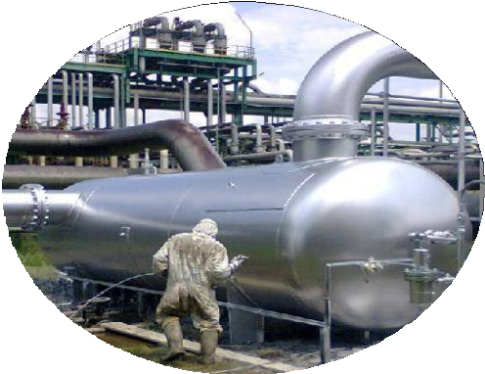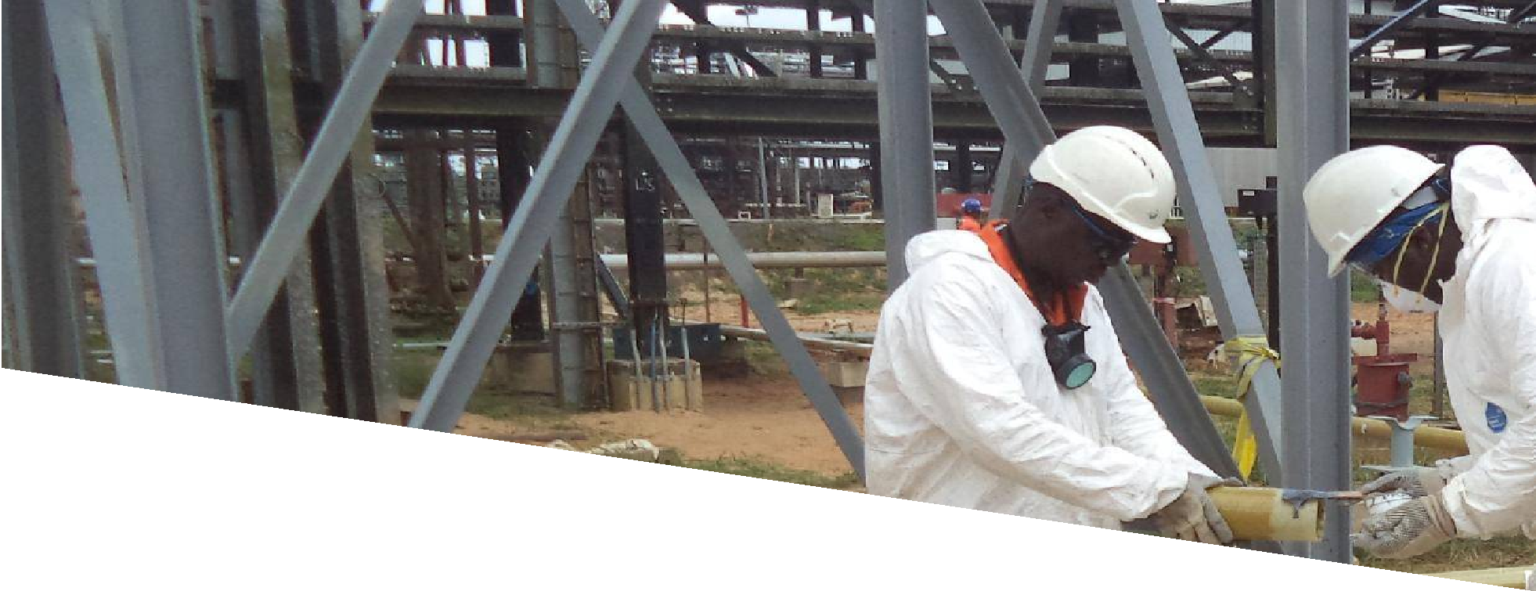

extensive experience providing engineering services and delivering solutions for oil and gas and energy facilities, both onshore and offshore. We support our clients in all the phases of an EPC project, from basic design to Commissioning.

VICBRIGGS NIGERIA LIMITED, have the capability to manage the personnel, plant and machinery, facilities

## WELDING

& FABRICATION

At VICBRIGGS, the versatility that comes from our expansive facility and extensive machining, welding, fabrication, and assembly capabilities makes us a resource of choice. Regardless of size or complexity—our custom metal fabrication services provide the broad range of capabilities required to suit the needs of all of our customers.

and technology so that our clients can focus on their core business strengths. Integrated work practices also include:

* + FACILITY AND INSTALLATION MAINTENANCE
  + MARINE EQUIPMENT MAINTENANCE
  + STRUCTURAL MAINTENANCE

We provide Mechanical Engineering service to projects of any scale.

### PIPELINE COATING, BLASTING & PAINTING

We use nothing but the best coating materials for all of our pipeline painting jobs. Our epoxy & polyurethane coatings materials used for blasting ensure that you'll be receiving the best results available, providing a heavy duty and durable coating to all of your pipelines.

**VViiccbbrriiggggss**

**N I G E R I A L I M I T E D**

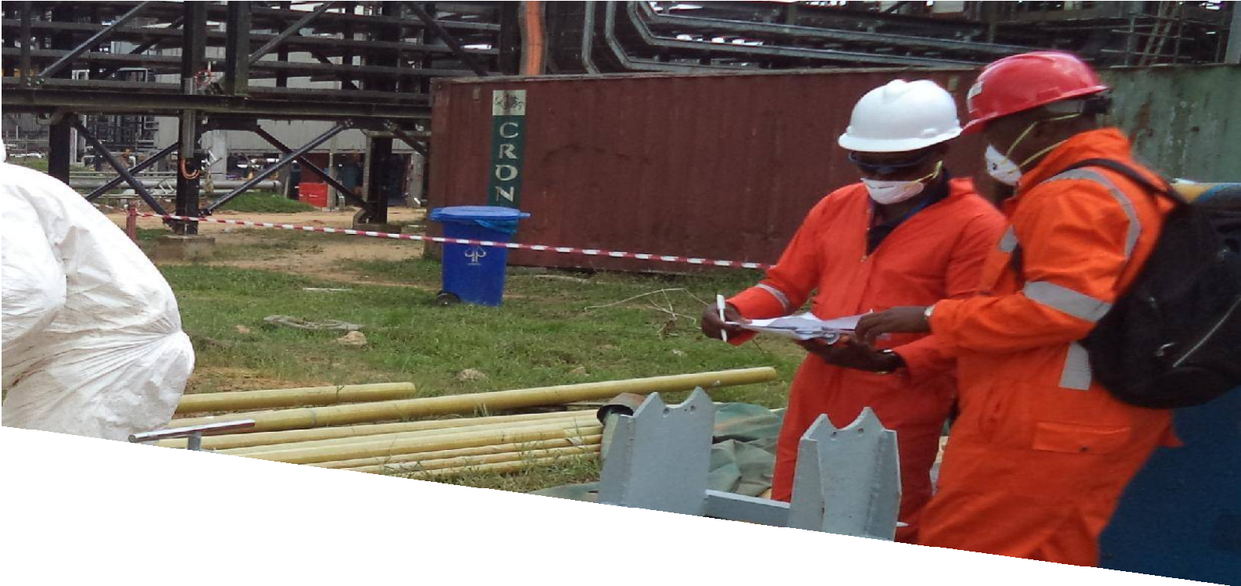

# w Onshore / Offshore Scaffolding w Corrosion Control Services

+ Overhead Tank Cleaning and maintenance

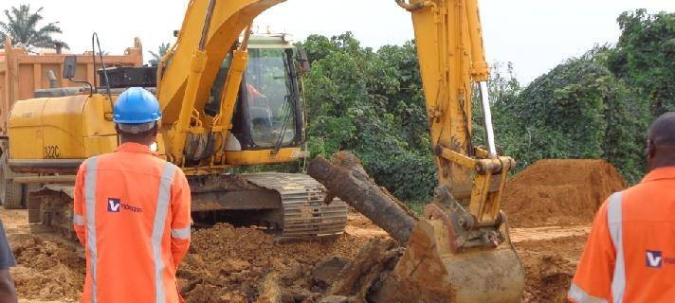

#### CORROSION CONTROL & BLASTING

###### This service which is usually sequel to inspection, is a remediation exercise carried out on corroded areas of plants, support structures & oil/gas delivery lines.

The company provides the following corrosion services:

* Coating
* Corrosion survey and risk assessment

Corrosion control in Process systems

Cathodic Protection for all above

ground and buried.

* Blasting and painting Insulation

**VViiccbbrriiggggss**

**N I G E R I A L I M I T E D**

**MARINE I CARGO SURVEY** | **STEVEDORING I ENGINEERING**

**ROJECTS**

At VICBRIGGS NIGERIA LIMITED, we are committed to taking pride in our work and producing a quality service that meets our clients expectation. If it can be measured, it can be improved upon; this is how our expectation on quality and performance is communicated to our project Teams. We have completed lots of projects in our about Mo decade of existence. Here are some of completed projects

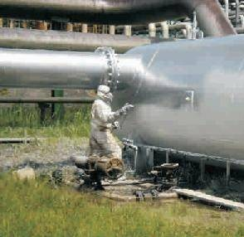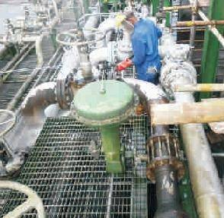

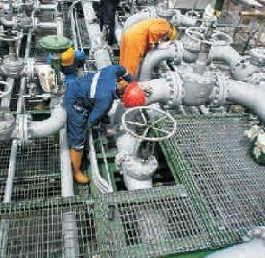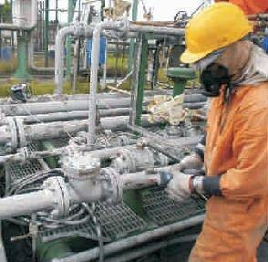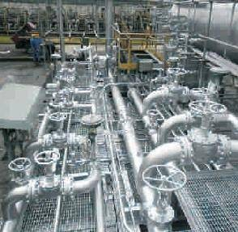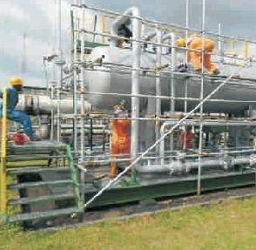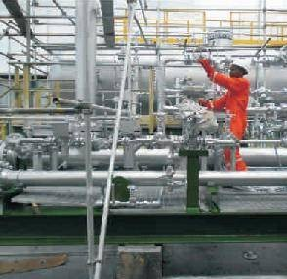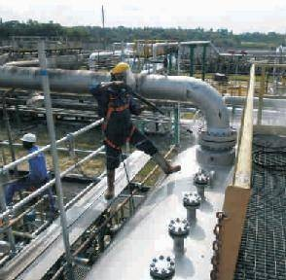

**VViiccbbrriiggggss**

**N I G E R I A L I M I T E D**

**MARINE** | CARGO SURVEY | STEVEDORING | ENGINEERING

**BRIGGS**

**TEC ICAL PARTNERS**

Its our culture in vICBRIGGS NIGERIA LIMITED to treat all our distinguished and reputable partners with high sense of responsibility, developing strong lasting friendship even as we ensure their interest is well protected. We always look forward to making you our partner.

We have been set up and managed by highly experienced personnel, with wide experience in the oil industry, to operate in accordance with internationally acceptable standards and practices in order to provide competitive, versatile and reputable service in the oil/gas and allied industry. The company's organizational chart is structured such as to ease reporting lapses and eliminate bureaucracy.

We have qualified, reputable, capable and seasoned professional onboard to ensure successful execution of projects we are involved in, irrespective of its magnitude and cost. The cardinal objective of the company is to provide high quality jobs execution to our various clients and the society at large. The collective commitments of our team to serve our clients better has lead to our success story in delivering timely quality services.

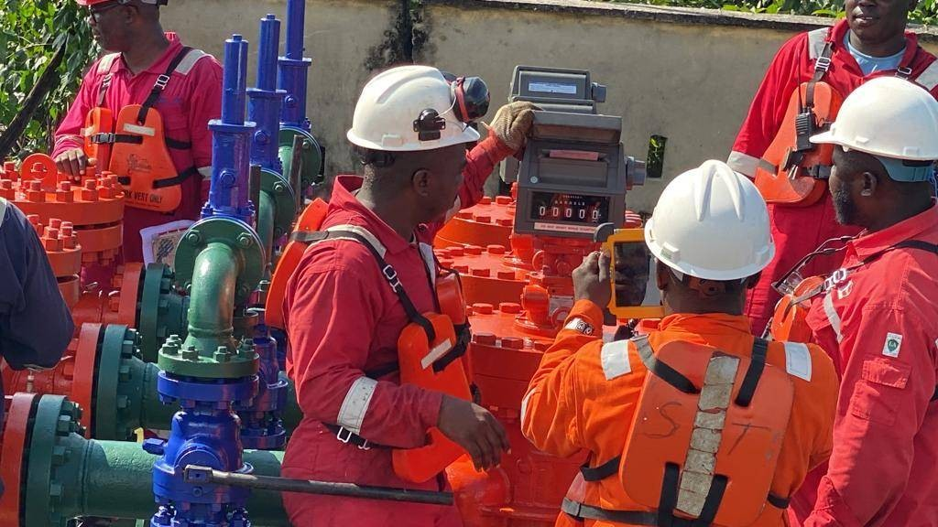

Its our culture in VICBRIGGS NIGERIA LIMITED to treat all our distinguished and reputable partners with high sense of responsibility, developing strong lasting friendship even as we ensure their interest is well protected.

We always look forward to making you our partner

MARINE I CARGO SURVEY | STEVEDORING I ENGINEERING

NTS

VICBRIGGS NIGERIA LIMITED has consistently rely on our friendship with our esteem clients and customers. We recognize that, there is no VICBRIGGS NIGERIA LIMITED Without our clients. Our secret has been our dedication to satisfy clients, their host communities and every regulatory agency attached to every job we do.

Our clients are changing the upstream and downstream sector of the Nigerian Economy. And we are proud to be part of that success in any little way. We are deeply appreciative to our clients for finding us worthy to serve.

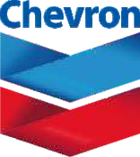IOC’s

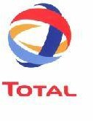

(Multi-Nationals)

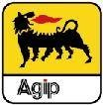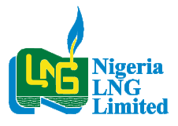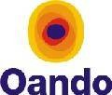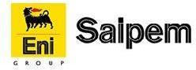

NOC’s

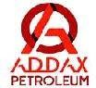  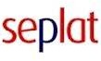

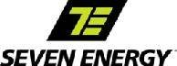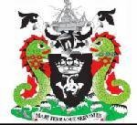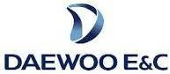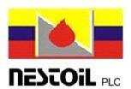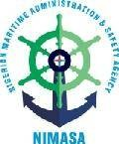Others

**VViiccbbrriiggggss**

**N I G E R I A L I M I T E D**



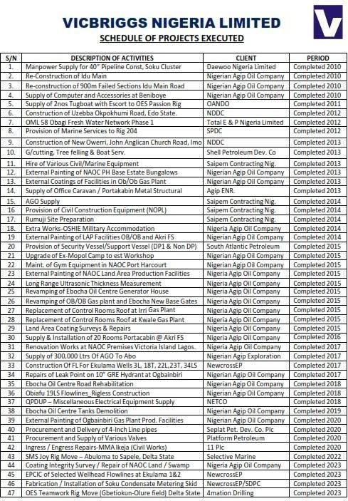

**VViiccbbrriiggggss**

**N I G E R I A L I M I T E D**

